Name:

**Assignment 1 GEOG 212**

*This assignment is worth 25 points and will be evaluated based on completeness, accuracy, and comprehensiveness, using the criteria, instructions, and the allocated points listed for each task in this document. Resources that may help you in completing this assignment include the course textbook, the modules and PowerPoints, and some on-line research (depending on the questions/tasks being asked of you).*

*Review this video on*[*How to Submit an Assignment in Blackboard*](https://bbaddins.schoolcraft.edu/addins/dl/help-videos/Assignment_Help_Video.html)*if you need assistance with this feature. See Calendar for due date. Please save your assignment as a Word document (don’t alter the format of this Word document) and type your name or initials at the end of the file name. Once completed and saved to a certain folder on your computer, go into the Assignment folder on Blackboard and upload your assignment accordingly.*

**Part 1.1 – Discovering Your Local Environment**

1. What city and state do you currently live in? ***[1 pt]***

|  |
| --- |
| Brighton, Michigan |

1. What natural resources are present in the region that you currently live in? List as many as you can find. ***[1 pt]***

|  |
| --- |
| Lakes, ponds, fish, forests, and wildlife |

1. What do you think is/are the largest environmental concern(s)/problem(s) where you live?  
    ***[1 pt]***

|  |
| --- |
| Due to the large amount of lakes in the area, and how many homes are built directly on the water, I think Brighton could suffer from a flooding problem in the next 10 years. |

1. What does sustainable development mean to you with regards to your community and local region? To answer this question, think about how you live your day-to-day life, what you consume in terms of resources such as water usage, chemical exposure (cleaners, deodorants, pesticides, etc.), energy consumption (electricity, fuel, etc.), and waste production. Your answer should be substantial and comprehensive. ***[4 pts]***

|  |
| --- |
| I’m going to start with what our community does well. Most people in Brighton are on well water, meaning most of our water (apart from heating) is purely mechanical and requires no electricity. The septic tanks still need to be emptied every 3 years, but I believe this approach is more sustainable. Apart from that, because Brighton is a smaller area, there are no restrictions on what you can waste. Want to run electronics 24/7? Go ahead! There is also zero public transportation, so everyone has a car which is not good for our wallets or our planet. For my day-to-day life I am not conscious of my impact, but I know it is bad. I buy whatever is the cheapest/most convenient. That usually means whatever I am buying is bad for the environment. My family goes through a lot of garbage, often having a second garbage can being full most weeks. |

**Part 1.2 – The Scientific Process**

The textbook describes the Fungal Attacker on Bats as an example of the scientific process at work. In this description, the textbook shows a figure that demonstrates one of many versions of the scientific process. Using this figure, answer the following questions:

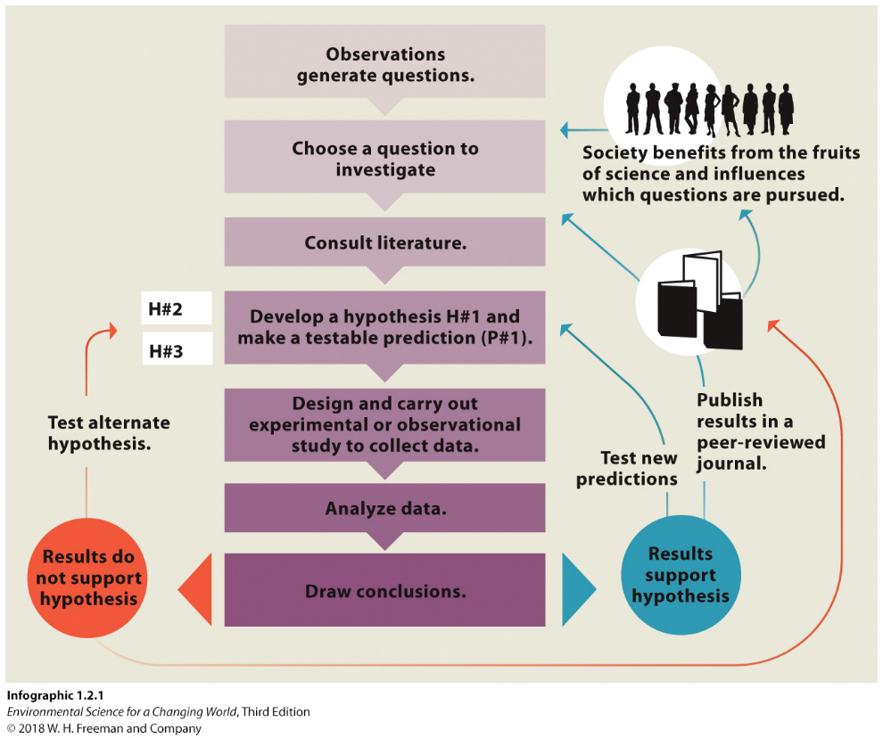

1. In what steps of the scientific process in the figure is the hypothesis tested? ***[1 pt]***

|  |
| --- |
| Step 5, design and carry out experimental or observational study to collect data. |

1. What are the two outcomes of an experimental study and what are the next steps for each of these outcomes? ***[1 pt]***

|  |
| --- |
| You have two outcomes, is your hypothesis true or is it false. If the hypothesis is true, you can test new predictions, publish results in a peer-reviewed journal, and release findings to the public. If the hypothesis is wrong, then you must test alternate hypothesis, or publish the findings in a peer-reviewed journal. |

1. To demonstrate a basic understanding of the scientific process, let’s design a simple but effective scenario for you to implement the scientific method for. You are presented with an observation and will need to complete the steps of the scientific process accordingly. Some steps have been completed for you: ***[8 pts]***

***Observation: You are on a camping trip with your two best friends and after a pleasant night of stargazing, you wake up to find that the pack of cookies you were snacking on the night before has disappeared from the picnic table you presumably left them on before you retired for the night.***

|  |  |
| --- | --- |
| Choose a question to investigate: | What happened to the Oreo cookies? |
| Consult Literature | The camping area has the following signs: “Do Not Feed Wildlife” “Secure Belongings at Night” |
| Develop Hypothesis H#1 *(Note: make sure this hypothesis is disproved first time around)* | My friends ate the Oreo cookies |
| Make a Testable Prediction (P#1) *Hint: write it as:  “ if (hypothesis statement) …then…”* | If they are not hungry in the morning then they must’ve ate the Oreo cookies. |
| Design an Experiment to Test your Prediction (E#1) | I will suggest pancakes or another sweet option for breakfast |
| Results/Conclusions  (allow the experiment to fail what you predicted the first time around) | My friends were very happy to eat pancakes for breakfast |
| Recycle Back to the Hypothesis and create a new one (H#2) | An animal ate the Oreo cookies |
| Prediction #2 (P#2) | A animal took the Oreos during the night because we left them out. |
| Experiment #2 (E#2) | If the box of Oreos is in a different location or looks damaged, it can be assumed it was not me or my friends. |
| Results/Conclusions  (allow the experiment to succeed this time around) | The box of Oreos was found a dozen yards away with crumbs everywhere and the box being mangled. |

1. Comment on the degree of certainty to the second hypothesis you created in the scenario above. Is there absolute proof regarding the fate of the cookies as described by your second hypothesis? In other words, is absolute irrefutable proof ever obtained in science? Explain your answer. ***[2 pts]***

|  |
| --- |
| There is not absolute proof that an animal ate the cookies. It could’ve been another group of campers, it could’ve been the wind even. Unless we were able to record the animal eating the cookies, followed the animal, and grabbed a stool sample, there is no absolute proof. Irrefutable proof is a misnomer as a scientific theory gains credibility because it can be tested again and receive further validation. |

**Part 1.3 – Information Literacy and Toxicology**

1. Explore the [Environmental Working Group website](http://www.ewg.org/) and search for and choose at least three substances (chemicals) that are carcinogens and fill the table below accordingly. For each carcinogen substance, you need to list it, describe its properties (smell, taste, color, liquid/gas, etc.), describe its effects, and the possible sources it may come from (both natural and human sources). ***[6 points]***

|  |  |  |  |
| --- | --- | --- | --- |
| Carcinogen Example *(be specific – this is a material, not a source)* | Properties | Effects  (could be more than one effect – be specific if you can) | Possible Sources |
| Teflon | Solid, not edible, plastic | Older pans have strong cancer links, headaches, illness. | Non-stick pans |
| Aspartame | Sweet, solid, dissolvable, looks like sugar | Cancer (in large doses), headaches and allergies, disrupt gut health | Zero Sugar/diet drinks or foods |
| Bisphenol A (BPA) | Solid material, not edible, plastic | Endocrine Disruptor, Reproductive Health, Cancer | Consuming foods or liquids that have been stored in containers containing BPA |